# Excel To WP Plugin Documentation

## Where to access the plugin?

In your admin dashboard, you can find the plugin in the left hand menu.

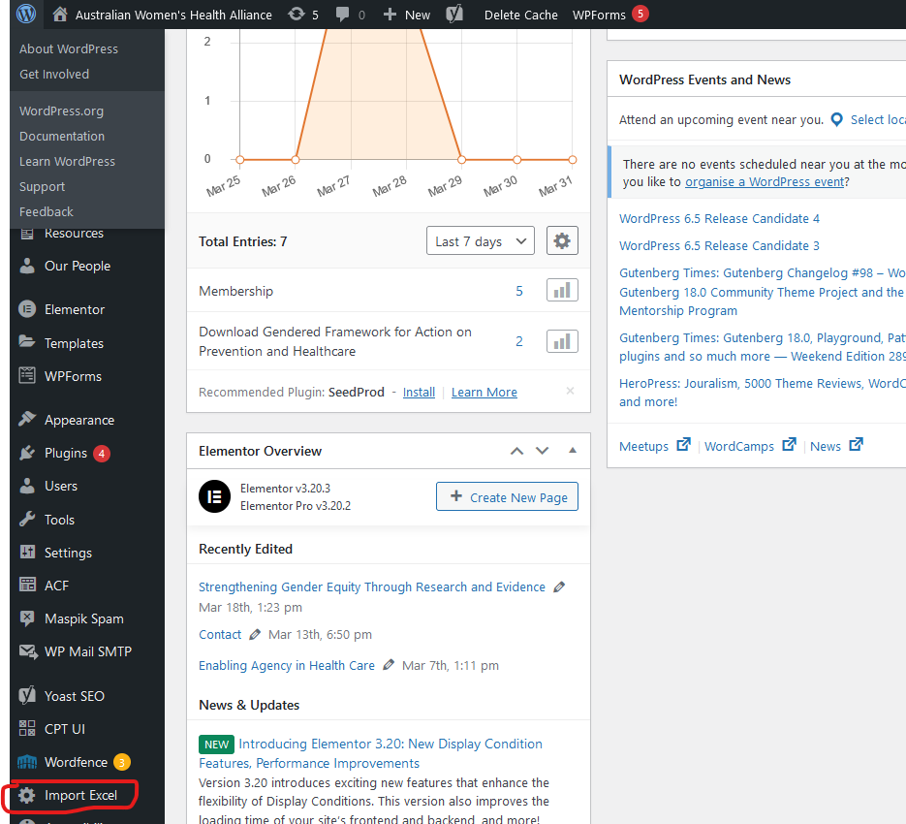

## How to upload new files

1. Press the Upload New Resouces button  
   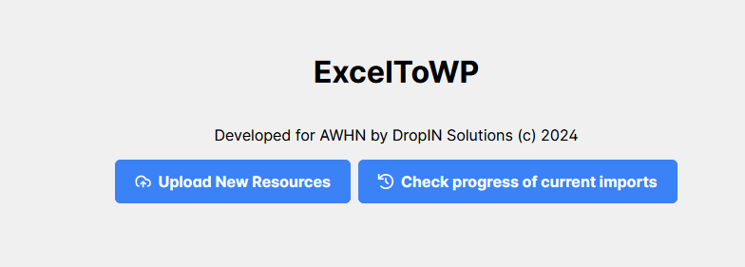
2. If you don’t have the upload template on your computer, please download it. If you already have the template, move on to step 3.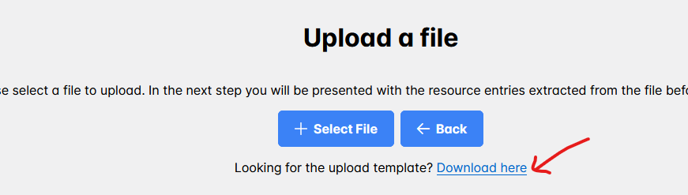
3. Paste your rows of resouces you would like to upload into the upload template.
   1. For example in the below screenshot, I copied rows 2,3,4 from the Resources spreadsheet:  
      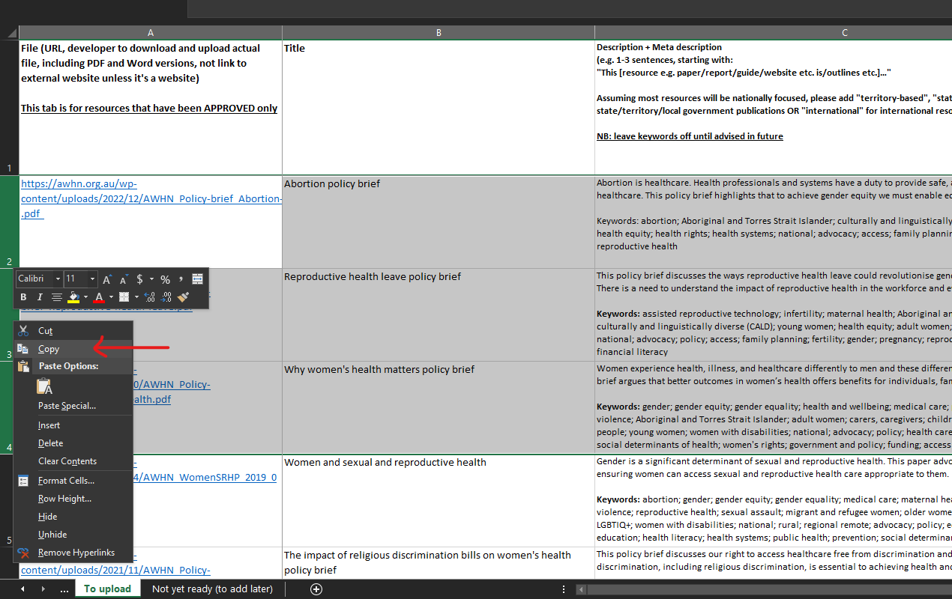
   2. Then paste them into the second row in the upload template (please ensure you do not remove the first row in the upload template:  
      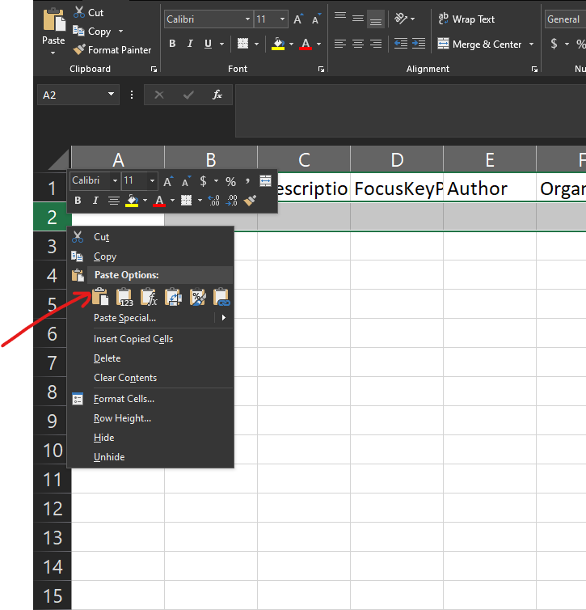
   3. Then save the upload template file to your computer
4. Press the blue Select File button on the plugin and choose the file you saved in step 3

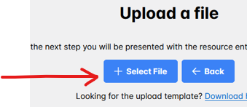

1. The plugin will now show the rows it can read from the uploaded file, and display any errors you need to fix before it can be uploaded:  
     
   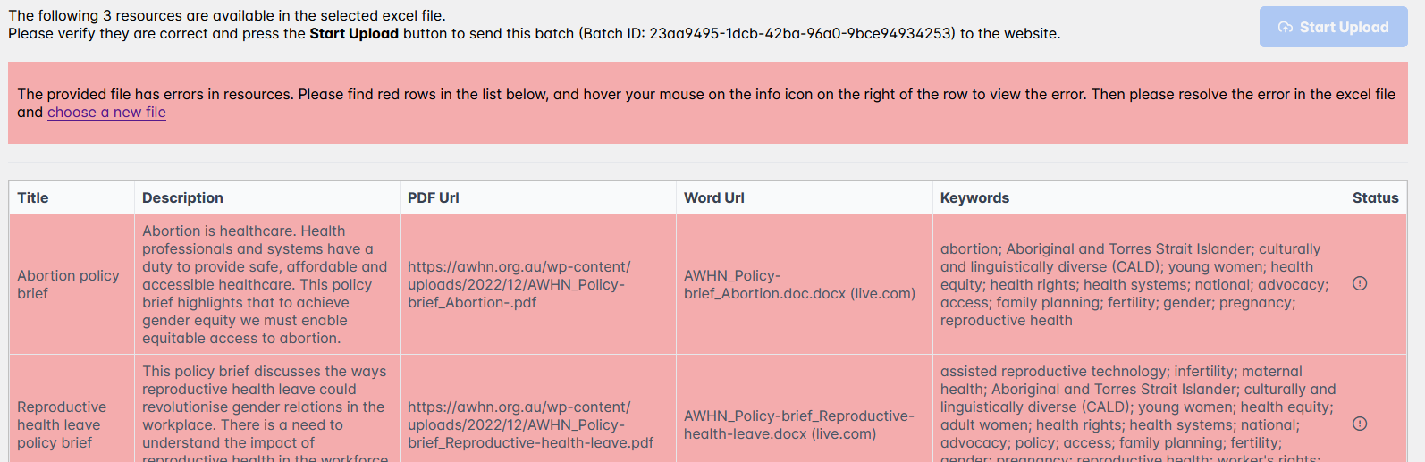  
   1. To view what the error with a given row is, please hover your mouse over the (i) icon on the Status:  
      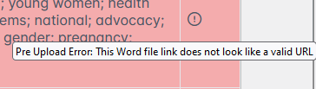
   2. You will have to edit the excel file you are trying to upload and fix the errors. The most common error is not having a title, or not having a word file link – The wordUrl and pdfUrl columns in the excel file have to be links (instead of text that displays as a normal text and links to somewhere upon clicking).
2. When the file is ready to upload, the “Start Upload” button on the top right will be activated. Please press this button to upload the files.
3. The Status icon for each resource row will change to reflect “processing” and then eventually “success”.
   1. If there are any errors in the upload process, you can hover over the status icon to see what the error is. The plugin is going to try to resolve errors if it can without any significant change to data (eg. it can auto correct special characters to fall back to their similar unspecial versions).
   2. If you notice a lot of errors, please contact us.
4. After the file has upload, you will find all the new resources in the Wordpress admin area under Resources as drafts or click on the Success icon to open that resource in a new tab:  
   